**To Create Lightning App Page in Salesforce, follow these steps:**

**Step-1:** First, log in to your salesforce Account.

**Step-2:** Then, open the setup page by clicking the Setup gear icon.

**Step-3:** Now in the Quick Find box, type “**app builder**” and select “**Lightning App Builder**” from the result. This will open the “**Lightning App Builder**” page.

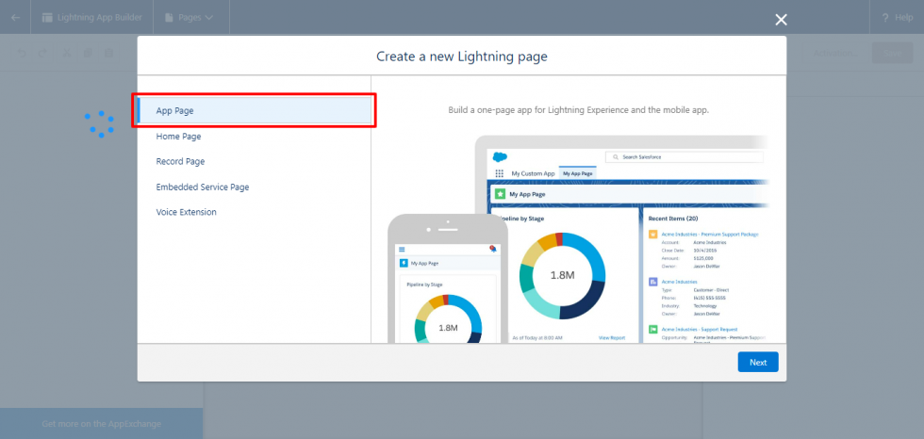

**Step-4:** Now on the App Builder page, click the “**New**” button to start the creation of a new page.

**Step-5:** Then, select the “**App Page**” as the page type and click the “**Next**” button.

**Step-6:** Then, enter the label for the lightning app page and then click the “**Next**” button.

**Step-7:** Further, choose the layout for the page and click the “**Finish**” button.

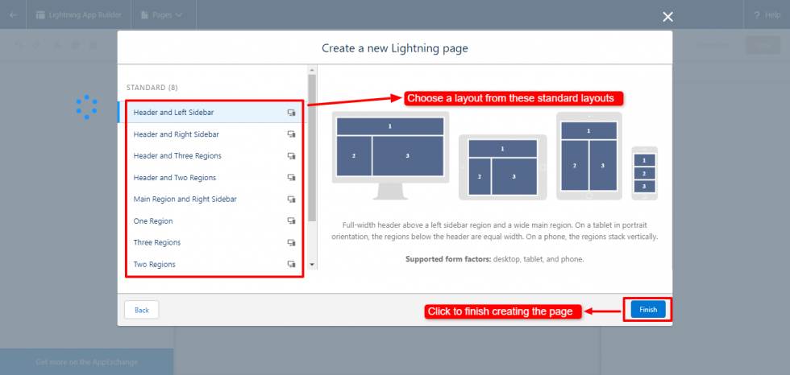

**Step-8:** Furthermore from the left sidebar, add standard and custom components to the page by dragging and dropping them. Then, click the “**Save**” button from the top-right corner.

**Step-9:** Then, a popup will appear for activating the page. Click the “**Activate**” button to open the activation page.

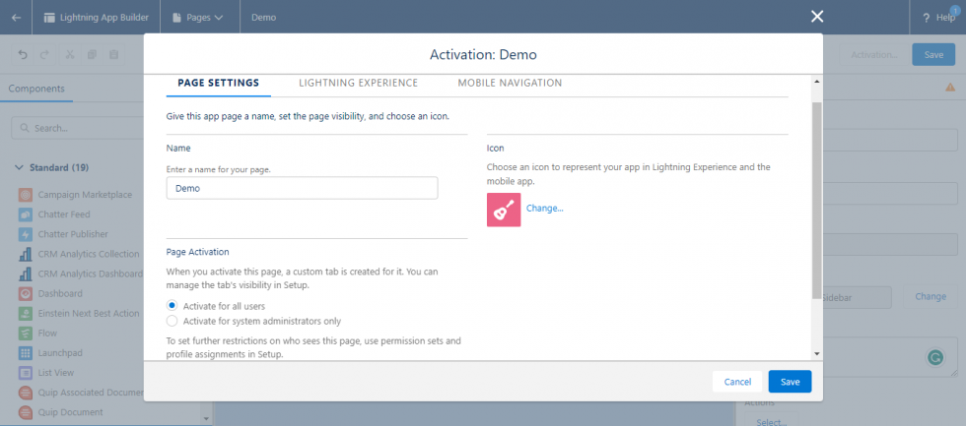

**Step-10:** Give a name to the page, set the page visibility, and choose an icon in the **Page setting**. Also in the **Lightning Experience**, add the page to the lightning apps and finally click the “**Save**” button to save the activation.